CENTRAL OFFICE TRANSFORMATION TOOLKIT

Creating Your Theory of Action for Districtwide Teaching and Learning Improvement

___________________________________________________________________________
WHAT’S IN THIS TOOL:
Theory of Action 1: A First Pass P. 4
Theory of Action 2: Taking It Deeper P. 7
Evidence and rationale: Student learning P. 9
Evidence and rationale: Teacher practice P. 11
Evidence and rationale: Principal practice P. 13
Evidence and rationale: Central office practice, structure, and systems P. 15
Theory of Action 3: Putting It All Together P. 17
___________________________________________________________________________

In this era of accountability, where the outcomes of American public education are highly scrutinized and hotly debated, school district central offices are under enormous pressure to lead instructional improvement and realize results. In response, many central offices are taking a close look at their staffing, organization, and practices and asking how they can be reimagined and redesigned to accelerate teaching and learning for all of their students. Recent research funded by the Wallace Foundation has given us a comprehensive picture of what this central office transformation looks like when it is done effectively. The research found that districts that have successfully transformed their central offices for better teaching and learning have focused on three areas of change:

- Creating strong learning-focused partnerships with principals that help principals grow as instructional leaders,
- Providing schools with high-quality, relevant services that directly support improved instruction, and
- Leading the change process by teaching and learning, together with staff throughout the system, what the new work is and how to engage in it.

Recreating the central office around these themes in a way that responds to the strengths and needs of an individual district and its people is a major undertaking that requires a clear rationale and the commitment, time, and engagement of many participants throughout the system if it is to succeed.

What this tool will help you do. This tool is designed to help a team of district leaders generate central office transformation plans that are grounded in a clear analysis of what is working and not working for their students and of how strengths and weaknesses in classroom teaching, principal instructional leadership, and ultimately central office practice, structures, and systems contribute to current student performance. The tool then helps the team to use that analysis to generate a theory of action, or an evidence-based story, that explains the specific changes you intend to make in the central office and why you believe these are the ones that will strengthen teaching and learning throughout the system. It also invites you to think about how you will engage, learn from, and communicate with staff throughout the system, in a spirit of teaching and learning, about why and how the system needs to change.

Research-Based Tools for
Central Office Transformation
____________________________________

The tools in this kit were created by the Center for Educational Leadership and Meredith I. Honig, Associate Professor of Education, at the University of Washington. They are based on a ground-breaking study, conducted by Honig and colleagues at the University of Washington, on how three school district central offices undertook to radically transform their central office into a true teaching and learning support system. That study, Central Office Transformation for District-wide Teaching and Learning Improvement, funded by the Wallace Foundation, investigated central office transformation efforts in three urban districts. These findings have since been confirmed and elaborated by a follow-up study, conducted by Honig and colleagues, involving six additional districts of varying sizes. In designing the tools we also drew on our direct experience helping districts of various sizes across the country get started with central office transformation.

This tool will help you to:

1. Develop a well-elaborated conception of the problem or situation for students, teachers, and leaders that motivates your actions in the first place.

A good theory of action does not simply elaborate which actions you plan to take. Rather, good theories of action stem from a careful analysis of what is motivating you to act in the first place. Too often leaders jump immediately to actions without fully examining or otherwise appreciating what is happening for students and adults. As a result, sometimes we invest considerable time, funding, and other resources in particular activities before we realize that what we have set out to do won’t actually get us where we want to go. If we had only suspended action and carefully examined what is happening in our settings, we might not have embarked on the wrong course.

2. Make your leadership the core of the theory of action.

The tool prompts you to consider not problems in general but problems of practice — problems in what people throughout the sytem do day-to-day and how they think about their work — that contribute to results for students. In particular, it asks you to look at the role of central office leaders. Even leaders who identify themselves as highly self-reflective and self-critical often focus on what school principals, school teachers, and parents need to do, without acknowledging or recognizing how their own actions or inactions are contributing to the conditions they are working to fix.

3. Create an evidence-based rationale for all parts of the theory.

There’s no shortage of problems and improvement strategies in education. But which problems are most pressing? Which problems are actually problems? Which strategies might actually work to address a particular problem? A theory-of-action approach to change sees the exploration of these questions as fundamental to charting a promising course for improvement. Exploring these questions requires relentless articulation of your rationale for your claims about problems and solutions and continual scrutiny of evidence to support your claims.

4. Identify the supports that practitioners will need in order to actually make the changes you have identified.

For example, if one of your leadership actions is that leaders will begin to provide high-quality feedback to teachers during classroom observations, what kinds of supports might leaders need to engage in those activities? If your teacher actions include that teachers will differentiate instruction effectively, what other conditions besides leaders’ feedback matter to teachers taking those actions? If you claim that teachers differentiating instruction will impact student achievement in reading, consider what other conditions affect student achievement in reading beyond what teachers do and identify those. The tool will walk you through these questions.

How to use this tool. The design of this tool assumes that its initial users are the superintendent and executive team. Given the depth of the inquiry process suggested here, the fact that it may extend over several sessions, and the need for discussion and consensus, it will probably be useful to have a facilitator to lead the group.

Beyond the initial team, though, practitioners at every level throughout the district will have important insights and feedback that help to shape the theory of action and make it stronger. Theories of action take time and many minds to develop, and never reach a final state. Rather, they are living documents that leaders continue to revisit and refine as they work with others to take action, collect evidence, and consider changing conditions. The conclusion of this tool asks you to think about how you will engage board members, parents, principals, teachers, central office staff, and perhaps even students in forming and carrying out your plans.

If you have not already done so, your team will find it helpful to work through another tool in this package, Readiness Assessment: Finding Your Starting Points for Central Office Transformation, before you work through this tool. The assessment takes you through a number of specific questions about your district’s culture, instructional expertise, central office budgetary and staffing capacity, leadership preparation, and a number of other areas that may bring issues to the surface that your theory of action should address.

Theory of Action 1: A First Pass

To begin, spend some time studying the theory of action graphic on the next page. To help you keep the big picture in mind as you begin the process, the image shows the connections that exist between the key players in the district: central office, principals, teachers, and students. (Note that this graphic is not intended to represent a district’s organizational chart or reporting lines, but simply to depict a set of relationships.)

Since the ultimate concern of central office transformation is with improving student learning, you’ll note that the graphic encourages you to begin deriving your theory of action not by jumping directly to perceived problems with teaching, principals, or the central office, but by focusing first on specific problems of student learning. It then asks you to work backward from there, analyzing how current practice, from teaching back through principal leadership to central office leadership and operations, is part of a chain of causality that produces the results in student performance that you see. This process yields a simple way to state a theory of action to undergird your work: “If the central office does X, then principals will be able to do Y, which will help teachers do Z, which will help all students to learn at higher levels.”

Continue to graphic on next page.

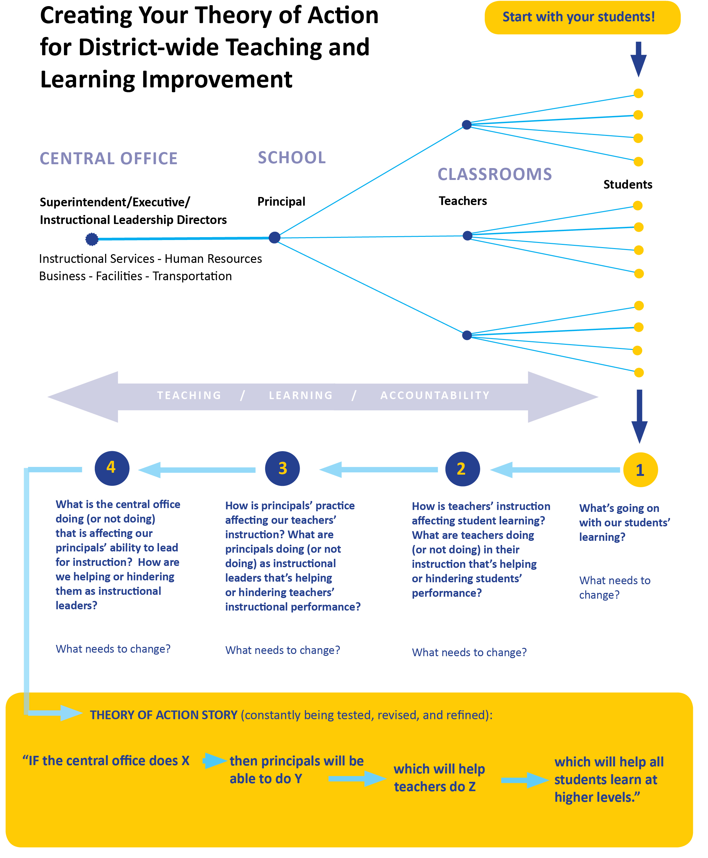

Now, to get started with a first rough draft theory of action that is specific to your district, work through the table on the next page, starting at the right and working down through each column before moving to the left. Then use your answers to rough out a basic theory of action at the bottom of the table. Your initial theory can be simple and impressionistic, just to give you a feel for the logic and the bare bones of your story. After you complete this beginning exercise, it’s important to continue on to the more detailed questions on the following pages, which will help you drill down into the causality and conditions for success in each part of the system in much more depth, giving your theory more power and accuracy.
START HERE:

4  Central Office |  | 3  Principals |  | 2  Teachers |  | 1  Students
4a. What is the central office doing (or not doing) that’s affecting our principals’ ability to lead for instruction? How are we helping or hindering them as instructional leaders?  Impressions and observations: |  | 3a. How is principals’ practice affecting our teachers’ instruction? What are principals doing (or not doing) as instructional leaders that’s helping or hindering teachers’ instructional performance?  Impressions and observations: |  | 2a. How is teachers’ instruction affecting student learning? What are teachers doing (or not doing) in their instruction that’s helping or hindering students’ performance?  Impressions and observations: |  | 1a. What’s going on with our students’ learning?  Impressions and observations:
4b. What needs to change in central office practice to better support principal instructional leadership? |  | 3b. What needs to change in principal practice to better support teachers’ instructional performance? |  | 2b. What needs to change in teacher practice to better support student learning? |  | 1b. What needs to change in our students’ learning?
ROUGH TAKE THEORY OF ACTION:

If the central office [does x][fill in the blank]..... | then principals will be able to.....[fill in the blank] |  | which will help teachers to....[[fill in the blank] |  | so that student learning will......
Theory of Action 2: Taking It Deeper

While your first broad-brush theory gives you a good starting point for discussion, it will not yet be detailed enough or sufficiently grounded in the evidence to give you a solid basis for effective action. To take your thinking to the next (deeper) level, take some time to look at the expanded theory of action graphic on the next page. This version includes more probing questions about your evidence for your claims about what’s going on in leadership, teaching and learning in your district, why you are prioritizing particular issues as problems, and what you think will help to remedy those problems and why. After looking over the graphic, continue on to page 9 to address the individual prompts on student learning, teaching practice, principal leadership, and the central office. (You may want to print the full graphic and give it to everyone, so that participants can keep the relationships between students, teachers, principals, and central office leaders in mind as you work through the questions.)

FACILITATION SUGGESTIONS: You may choose either to have each of the participants do some private writing in response to the prompts first, and then capture their thoughts on wall charts; or simply facilitate and chart a group discussion about each prompt from the beginning. Either way, you will want to have the group’s thinking visible to all. While there may be a desire to skip ahead through the sequence of prompts, we suggest you try to keep to the order given. This will help to maintain the logic of working from students’ needs back to the central office, and from problem descriptions to evidence to the rationale for change and the supports that will be needed for success.

Note that working your way all the way through all of these questions will be, and should be, a much longer process than your first-take theory of action discussion. As you make your way through the process, you may turn up areas where you need to collect more evidence (by looking at student data, conducting classroom walkthroughs, or having conversations with key school-based personnel) or to consult the research on effective practice before your theory can be solidified. You don’t need to hold back from sketching out your theory until you fill in all such gaps (you will be revisiting it frequently in any case). But do note areas where you need more information.

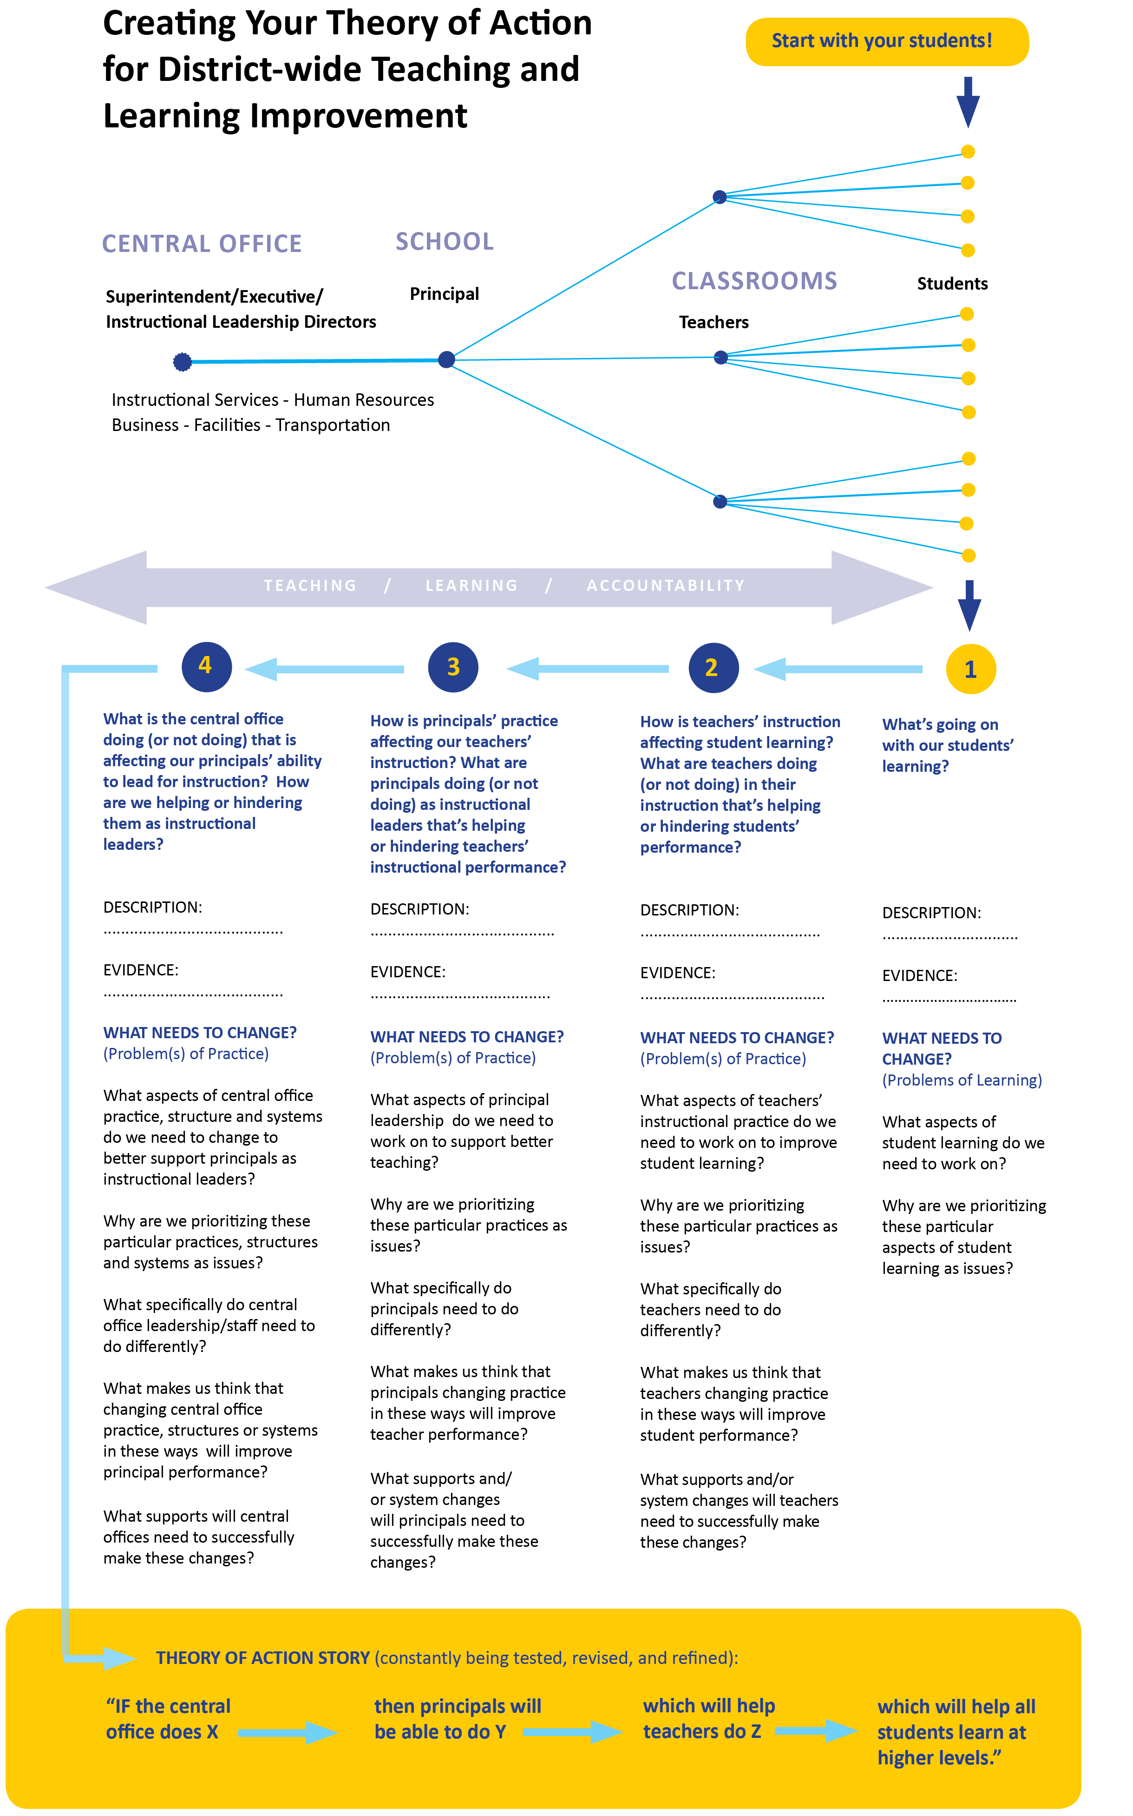
Working through the Prompts: Evidence and Rationale

1. STUDENT LEARNING

What’s going on with our students’ learning?

A. DESCRIPTION or ANECDOTE:
Which student in our system well captures what most concerns us about student learning in our system? What specifically is happening for that student? For example, what does a typical day look like for that student in terms of his or her learning experience? How prevalent do we think these issues are?

B. EVIDENCE/DATA:
What evidence of student performance do we have that substantiates our concerns above?
(from performance data, observations/rounds/walkthroughs, and/or conversations with teachers and parents)

What needs to change in our students’ performance? (Problems of learning)

C. Given our observations and the evidence above, what aspects of student learning do we need to work on?

D. Why are we prioritizing these particular aspects of student learning as issues?

E. What changes in teacher practice or other instructional resources do we think will make a difference?

Working through the Prompts: Evidence and Rationale

2. TEACHING PRACTICE

How is our teachers’ instruction affecting our students’ learning?
What are teachers doing (or not doing) in their instruction that’s helping
or hindering students’ performance?

A. DESCRIPTION/ANECDOTE:
Which one teacher in our system well captures what most concerns us about the quality of teaching in our system given the issues we see in student learning? What specifically does that teacher do in his or her practice that concerns us? For example, what might that teacher be doing during a typical math lesson in terms of how he or she interacts with students?

B. EVIDENCE/DATA:
What evidence do we have (or could we collect or consult) that substantiates the problem that this teacher represents — for example, how prevalent that kind of teaching is among which teachers in which schools, and how it’s affecting student performance?

What needs to change in teachers’ practice? (Problem(s) of practice)

C. Given the issues we see in student learning, what aspects of teachers’ instructional practice do we need to work on to improve student learning?

D. Why are we prioritizing these particular practices as issues?

E. What specifically do teachers need to do differently?

F. What makes us think that teachers changing their practice in these ways will improve student learning?

G. What supports and/or system changes will teachers need to make these changes successfully? (Consider also external forces, such as unions, that will have a bearing on necessary changes.)

Working through the Prompts: Evidence and Rationale

3. PRINCIPALS’ PRACTICE

How is our principals’ practice affecting our teachers’ instruction? What are our principals doing (or not doing) as instructional leaders that’s helping or hindering teachers’ instructional performance?

A. DESCRIPTION/ANECDOTE:
Given the issues you’ve identified in teacher practice, which one principal in your system well captures what most concerns you about the quality of principal leadership in your system? What specifically does that principal do in their practice that concerns you? For example, what might that principal be doing on a typical Wednesday morning?

B. EVIDENCE/DATA:
What evidence do you have (or could you collect or consult) that could help you understand the scope of the problem that principal represents — for example, how prevalent that kind of leadership is among which principals in which schools, and how it’s affecting teacher performance?

What needs to change in principal leadership? (Problem(s) of practice)

C. Given the issues we’ve identified in teacher performance, what aspects of principal leadership do we need to work on?

D. Why are we prioritizing these particular practices as issues?

E. What specifically do principals need to do differently?

F. What makes us think that principals changing their practice in these ways will improve teacher performance?

G. What supports and/or system changes will principals need to make these changes successfully? What resources will be required?

Working through the Prompts: Evidence and Rationale

4. CENTRAL OFFICE PRACTICE, STRUCTURE, AND SYSTEMS

What is the central office doing (or not doing) that’s affecting our principals’ ability to lead for instruction? How are we helping or hindering them as instructional leaders?

A. DESCRIPTION/ANECDOTE:
Given the issues we’ve identified in principal instructional leadership practice, which one central office administrator in our system well captures what most concerns us about the quality of central office leadership in our system? What specifically does that central office administrator do in his or her practice that concerns us? For example, what have we observed that central office administrator doing or not doing in a meeting, or in visiting (or not visiting) schools?

B. EVIDENCE/DATA:
What evidence do we have (or could we collect or consult) that could help us understand the scope of the problem that central office administrator represents — for example, how prevalent that kind of leadership is among which central office staff? In which units?

What needs to change in the central office? (Problem(s) of practice)

C. Given the issues we’ve observed in principal instructional leadership, what aspects of central office staff practice, structure, and systems do we need to change to better support principals as instructional leaders?

D. Why are we prioritizing these particular practices, structures and systems as issues?

E. What specifically do central office leadership/staff need to do differently? How do structures and systems need to change?

F. What makes us think that changing central office practice, structure or systems in these ways will improve principal performance?

G. What support and/or system changes will central offices need to make these changes successfully? What new resources will be needed?

Theory of Action 3: Putting It All Together

Once you’ve finished working through the questions above sequentially, you’ll want to consider your responses to all of them simultaneously, working back from the issues for student learning on the right all the way to central office practices, structures and systems on the left as shown in the graphics. In your discussion, highlight the relationships between the issues you’ve identified. In particular, it will be helpful to focus on your answers to question C (“What needs to change?”) in each area in order to promote effective instructional leadership and better teaching. Provided that you’ve developed a solid rationale for what needs to change in each case, by capturing your answers to that question, you should now be able to generate a revised theory of action that goes deeper than your first:

REVISED THEORY OF ACTION:

If the central office [does x]..... | then principals will be able to..... | which will help teachers to.... | so that student learning will......

As mentioned, even this revised theory of action will be subject to continual reassessment and revision as you lead, teach and learn your way through the work of transforming the central office in support of improved student learning. Even now, looking at your answers to questions B (about evidence) and F (“What makes us think this will work?”), it may be clear to you that you need to gather stronger evidence or consult more research in order to back up parts of your theory.

Questions you might consider as you look ahead from here to develop an action plan:

1. How will we fill in any current gaps in our evidence or research base as we look at our theory of action?

2. How will we use our theory of action? Which audiences do we need to engage in dialogue with about our theory of action and why?

3. What are the most important things that we need to convey to these audiences about our theory of action and the need for change? In what ways do we need their support?

4. What process will we follow to regularly revisit and update our theory of action, either formally or informally, as our work moves forward over the coming months and years?

