TOOL
SUSTAINABILITY PLANNING: ACTION PLAN
The following worksheets are part of the Sustainability Planning Tools. For detailed guidance on how to organize and facilitate your sustainability planning process using the Tools, review the Sustainability Planning Facilitation Guide.

PURPOSE
Use this worksheet to organize and expand upon the potential strategies and action steps you identified in the Self-Assessment and Strategy Development tools. Create clarity through a common focus that prioritizes the strategies and steps that are most critical, feasible, and potentially impactful. Aim for increased accountability and efficiency in how departments and partners should work together to deliver on the plan.
CONTENTS
There are four main sections in this worksheet: Updated Shared Mission and Vision, Program Plan, Organization and Community Plan, and Policy and Funding Plan.

UPDATED SHARED MISSION AND VISION STATEMENT

Before you lay out your Action Plan, revisit your shared mission and vision statement for your program that reflects the shared goals and values of all partners. Use the table below to document new ideas for your mission and vision statement. Some questions to consider: What do we seek to achieve through our summer learning program? Why is the program important? What benefits does the program provide for youth, families, and the community? What’s the value proposition?
UPDATED SHARED MISSION AND VISION

INSTRUCTIONS
Outline your action plan for each focus area: Program, Organization and Community, and Policy and Funding. Use the prompts in the box below as a guide.
For each of the three focus areas, identify or select 1-2 potential strategies from the Self-Assessment and Strategy Development tools that are most feasible and potentially impactful.
FIRST COLUMN: ACTION STEPS
For the identified strategy, what are the actions we me must take to make progress?
SECOND COLUMN: ROLES AND RESPONSIBILITIES
Who is responsible for taking action or tracking progress? Who should be engaged?
THIRD COLUMN: TIMEFRAME
What is the necessary or anticipated timeframe?
FOURTH COLUMN: EXPECTED RESULTS
What are the expected outcomes or results of our efforts?
Additional guiding questions for team planning conversations and tips for effective planning and facilitation are available in the Sustainability Planning Facilitation Guide.

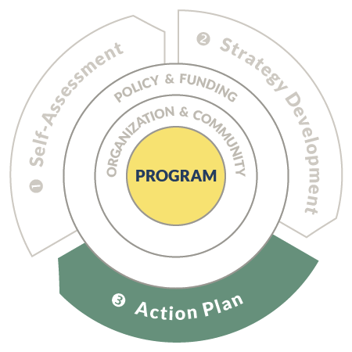

Prioritize 1-2 strategies for your Program Action Plan. List the Action Steps for the strategy, itemizing roles, timeframe, and expected results for each action.

STRATEGY #1.
List the strategy in the space to the right.
ACTION STEPS | ROLES AND RESPONSIBILITIES |  | TIMEFRAME | EXPECTED RESULTS

STRATEGY #2.
List the strategy in the space to the right.
ACTION STEPS | ROLES AND RESPONSIBILITIES |  | TIMEFRAME | EXPECTED RESULTS

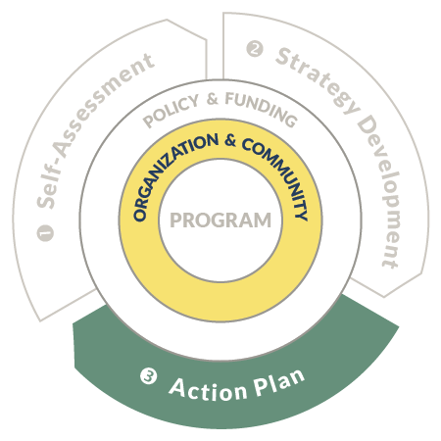

Prioritize 1-2 strategies for your Organization and Community Action Plan. List the Action Steps for the strategy, itemizing roles, timeframe, and expected results for each action.

STRATEGY #1.
List the strategy in the space to the right.
ACTION STEPS | ROLES AND RESPONSIBILITIES |  | TIMEFRAME | EXPECTED RESULTS

STRATEGY #2.
List the strategy in the space to the right.
ACTION STEPS | ROLES AND RESPONSIBILITIES |  | TIMEFRAME | EXPECTED RESULTS
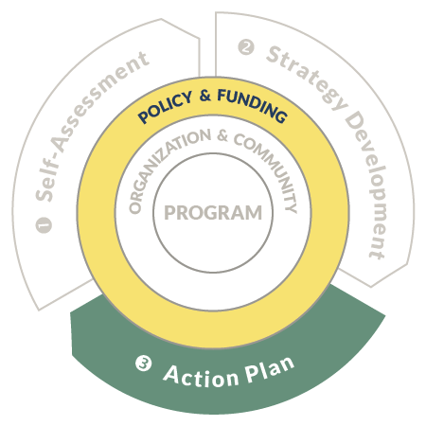

Prioritize 1-2 strategies for your Policy and Funding Action Plan. List the Action Steps for the strategy, itemizing roles, timeframe, and expected results for each action.

STRATEGY #1.
List the strategy in the space to the right.
ACTION STEPS | ROLES AND RESPONSIBILITIES |  | TIMEFRAME | EXPECTED RESULTS

STRATEGY #2.
List the strategy in the space to the right.
ACTION STEPS | ROLES AND RESPONSIBILITIES |  | TIMEFRAME | EXPECTED RESULTS

