TOOL
SUSTAINABILITY PLANNING: STRATEGY DEVELOPMENT
The following worksheets are part of the Sustainability Planning Tools. For detailed guidance on how to organize and facilitate your sustainability planning process using the Tools, review the Sustainability Planning Facilitation Guide.

PURPOSE
Strategy Development comprises the majority of sustainability planning work. The worksheets in this tool help you to collect and organize information related to the purpose of the program, its key organizational and community stakeholders, and its policy and funding context. These exercises will engage you in brainstorming strategies and action steps to strengthen quality, alignment, engagement, messaging, and support.
CONTENTS
This tool guides you through strategy development in three main areas: Program, Organization and Community, and Policy and Funding.
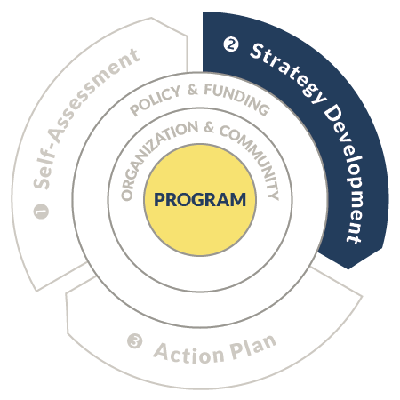

The PROGRAM section of this tool asks you to document the shared mission and vision and core elements of your program alongside the strategic priorities of your district and community. The goal is to help you understand and articulate how summer learning fits into and strengthens your local learning ecosystem and to determine what it is that you want to sustain when faced with leadership changes or varying funding levels from year to year. These worksheets guide you through four areas:
- Shared Mission and Vision Statement
- Core Program Elements
- Goal and Priority Alignment
- Potential Strategies for Action Plan

- SHARED MISION AND VISION STATEMENT
Use the worksheet below to document or develop a mission and vision statement for your program that reflects the shared goals and values of all partners. Some questions to consider: What do we seek to achieve through our summer learning program? Why it the program important? What benefits does the program provide for youth, families, and the community? What’s the value proposition?
SHARED MISSION AND VISION

2. CORE PROGRAM ELEMENTS

This worksheet will help you analyze the core elements of your program. Use the prompts in the box below as a guide when you fill out this part of the Strategy Development tool. To see sample entries, visit the Sustainability Planning Facilitation Guide.
FIRST COLUMN: CORE ELEMENTS OF THE SUMMER PROGRAM
List the elements of your summer program(s) that are essential features. In other words, which features of your planning, staffing, and program design are critical to ensure quality and outcomes for youth?
SECOND COLUMN: ASSOCIATED BENEFITS AND OUTCOMES
List the demonstrated outcomes and assumed benefits for each Core Element you have listed.

CORE ELEMENTS OF THE SUMMER PROGRAM | ASSOCIATED BENEFITS AND OUTCOMES

3. GOAL AND PRIORITY ALIGNMENT

The following worksheets will help you identify the strategic goals and priorities of your district and community. Use the prompts in the box below as a guide when you fill out this section of the Strategy Development tool.
FIRST COLUMN: STRATEGIC GOALS AND PRIORITIES
List the strategic goals and priorities of your district and community. Reference organizational websites and strategic plans when available.

SECOND COLUMN: HOW THE SUMMER PROGRAM FURTHERS THESE GOALS
Consider whether the priorities are supported by features of your summer program and if so, how. What are the documented outcomes or assumed benefits of your program that demonstrate its alignment to organization and community priorities?

O  R  G  A  N  I  Z  A  T  I  O  N | STRATEGIC GOALS AND PRIORITIES | HOW THE SUMMER PROGRAM FURTHERS THESE GOALS

C  O  M  M  U  N  I  T  Y | STRATEGIC GOALS AND PRIORITIES | HOW THE SUMMER PROGRAM FURTHERS THESE GOALS

4. POTENTIAL STRATEGIES FOR ACTION PLAN

Reviewing your work in this section, list Potential Strategies for Action Plan in the worksheet below.

GUIDING QUESTION
- Given our discussions and findings, what program-related strategies or action steps should we consider for our Action Plan?
HELPFUL TIPS
- When brainstorming program-focused strategies or action steps, revisit the Self-Assessment tool and consider annual continuous improvement findings to develop strategies that may help contribute to improved quality and attendance.
- In addition to the Self-Assessment, consider your most recent end-of-summer recommendations for improving program quality and operations here.

POTENTIAL STRATEGIES FOR ACTION PLAN

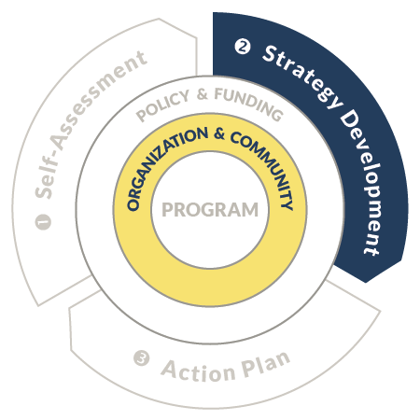

The ORGANIZATION AND COMMUNITY section of this tool prompts you to identify whom from your Organization and Community you’ll need to engage to secure long-term support. These worksheets guide you to consider:
- Stakeholder Engagement
- Potential Strategies for Action Plan

As you fill out the Stakeholder Engagement worksheets, use the prompts in the box below as a guide.
FIRST COLUMN: STAKEHOLDER
Who from lead or partner organizations and the community is essential to sustain or develop supportive policies and systems for our summer learning program?
SECOND COLUMN: CURRENT SUPPORT
What is their current level of awareness of our program’s value and alignment to district and organizational priorities? Refer back to the Goal and Priority Alignment worksheet in this tool for helpful context.
THIRD COLUMN: ROLE AND CONTRIBUTION
How can they contribute to our goals and plans for sustainability? What specific roles could they play? Consider: Planning team, advisory team, or other roles specific to the stakeholder group.
FOURTH COLUMN: MESSAGES
Based on the priorities we identified, what information or messages about summer learning align to their interests or could help enlist their support? Refer back to the Goal and Priority Alignment worksheet in this tool for helpful context.

- STAKEHOLDER ENGAGEMENT

Refer to the prompts in the yellow box on the previous page for information on how to fill out these worksheets.
O  R  G  A  N  I  Z  A  T  I  O  N | STAKEHOLDER | CURRENT SUPPORT | ROLE AND CONTRIBUTION | MESSAGES

C  O  M  M  U  N  I  T  Y | STAKEHOLDER | CURRENT SUPPORT | ROLE AND CONTRIBUTION | MESSAGES

2. POTENTIAL STRATEGIES FOR ACTION PLAN

Reviewing your work in this section, list Potential Strategies for Action Plan in the worksheet below.
GUIDING QUESTION
- Given our discussions and findings, what organization- and community-related strategies or action steps should we consider for our Action Plan?

POTENTIAL STRATEGIES FOR ACTION PLAN

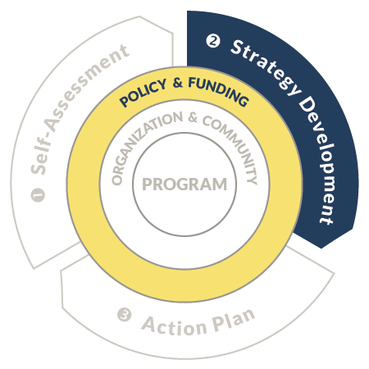

The POLICY AND FUNDING section of the Strategy Development tool helps you analyze your policy and funding landscape to identify opportunities and barriers to sustaining summer learning. These worksheets guide you to consider:
- Policy
- Funding
- Potential Strategies for Action Plan

- POLICY
The following worksheet will help you identify the opportunities and challenges within the policy context. Use the prompts in the box below as a guide.
Begin by adding the appropriate dates to the three bracketed areas in the header under TIMEFRAME.
FIRST SET OF ROWS: DISTRICT/ORGANIZATION
List the strengths/opportunities and challenges/obstacles at the district/organization level of policy, now and into the future.
SECOND SET OF ROWS: CITY/COMMUNITY
List the strengths/opportunities and challenges/obstacles at the city/community level of policy, now and into the future.
THIRD SET OF ROWS: STATE
List the strengths/opportunities and challenges/obstacles at the state level of policy, now and into the future.

 |  | TIMEFRAME
 |  | NOW:  [enter date here] | 1-3 YEARS INTO FUTURE:  [enter target date here] | 3+ YEARS INTO FUTURE:  [enter target date here]
DISTRICT / ORGANIZATION | OPPORTUNITIES
 | CHALLENGES
CITY/ COMMUNITY | OPPORTUNITIES
 | CHALLENGES
STATE | OPPORTUNITIES
 | CHALLENGES

- FUNDING

The following worksheet will help you analyze current and potential funding sources. Discuss the rationale for categorizing sources as you complete the process, including your knowledge of funding ranges and depth of the application, compliance, and reporting requirements. Use the prompts in the box below as a guide to fill out the worksheets.
FIRST COLUMN: FUND NAME AND SOURCE
For both current and potential funding sources, identify the fund name and source.
SECOND COLUMN: AMOUNT
For each source, include the estimated funding range (if ranges are unknown, rate low, medium, high).
THIRD COLUMN: ELIGIBILITY CRITERIA AND REQUIREMENTS
Determine the level of effort required to secure and maintain funding.
FOURTH COLUMN: FUNDING TIMELINE
Identify the time horizon for each source.
FIFTH COLUMN: LIKELIHOOD OF RENEWAL/SECURING
Rate the likelihood of renewing or securing funding from each source (low, medium, high).

C  U  R  R  E  N  T | FUND NAME AND SOURCE | AMOUNT | ELIGIBILITY CRITERIA AND REQUIREMENTS | FUNDING TIMELINE | LIKELIHOOD OF RENEWAL

P  R  O  S  P  E  C  T  S | FUND NAME AND SOURCE | AMOUNT | ELIGIBILITY CRITERIA AND REQUIREMENTS | FUNDING TIMELINE | LIKELIHOOD OF SECURING

3. POTENTIAL STRATEGIES FOR ACTION PLAN

Reviewing your work in this section, list proposed Potential Strategies for Action Plan in the worksheet below.
GUIDING QUESTION
- Given our discussions and findings, what policy- and funding-related strategies or action steps should we consider for our Action Plan?

POTENTIAL STRATEGIES FOR ACTION PLAN

